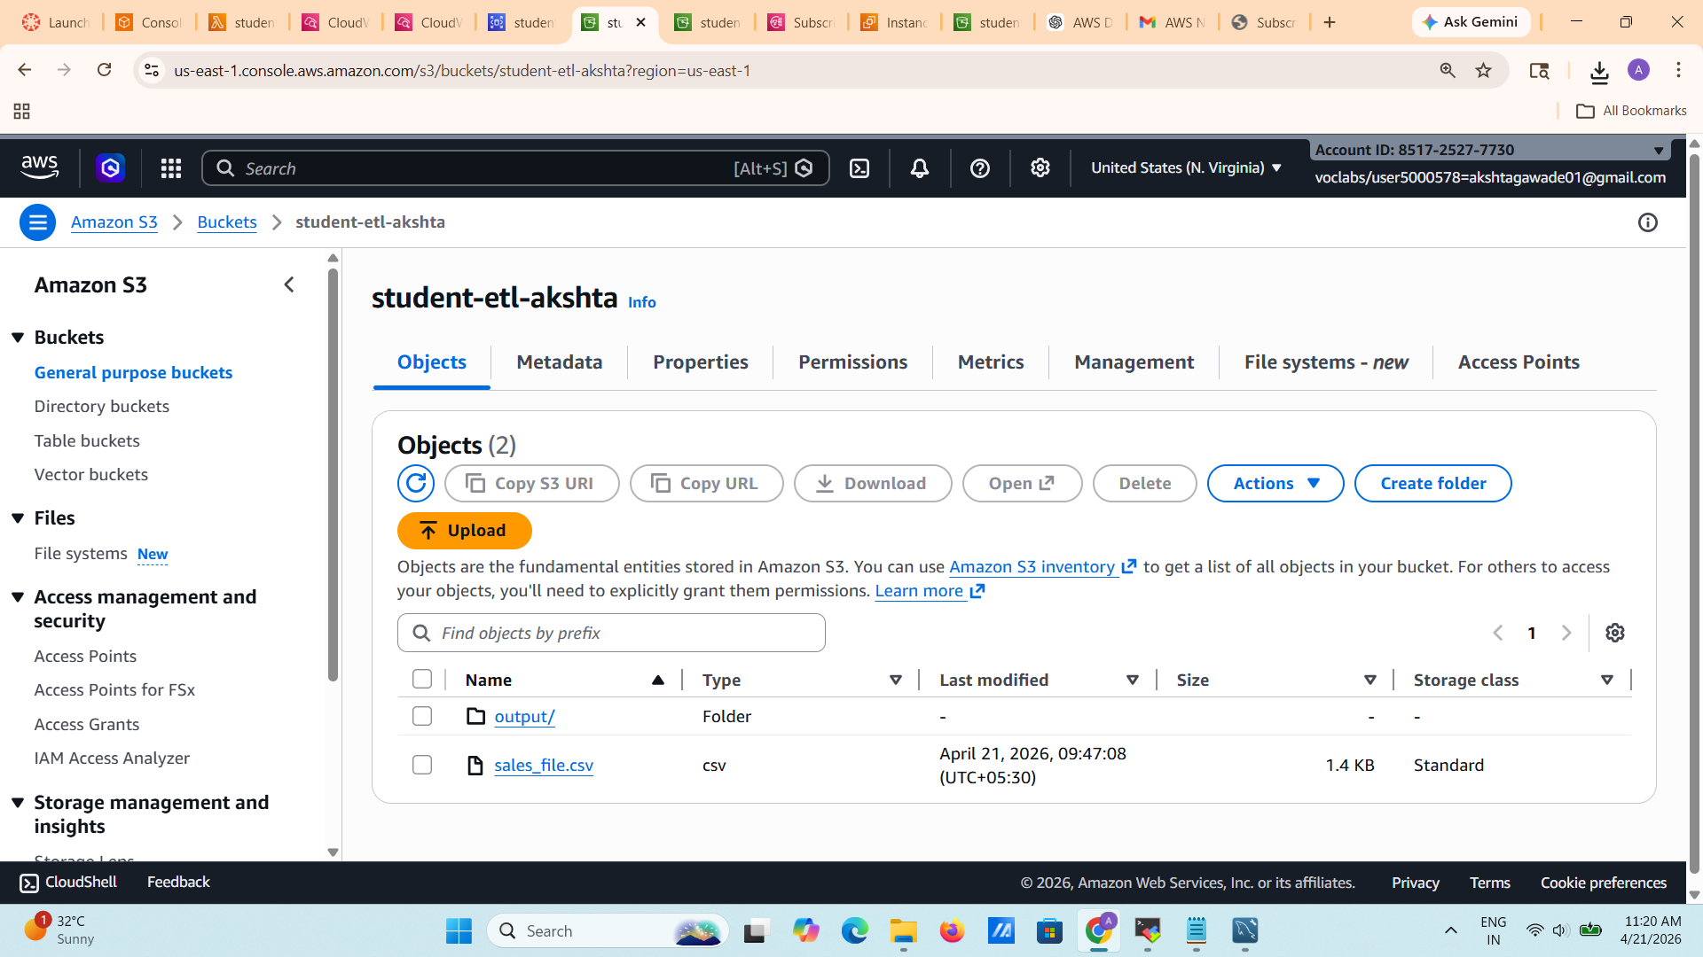

Lambda code for q.2
import boto3
import pandas as pd
import io
import pymysql
from datetime import datetime

s3 = boto3.client('s3')
sns = boto3.client('sns')

TOPIC_ARN = "arn:aws:sns:us-east-1:851725277730:student-processing-topic:b45016eb-0b46-47d6-b02d-c279cc09ed5b"

DB_HOST = "studentdb.ct08esq02var.us-east-1.rds.amazonaws.com"
DB_USER = "admin"
DB_PASS = "mypass1234"
DB_NAME = "studentdb"

def lambda_handler(event, context):

bucket = event['Records'][0]['s3']['bucket']['name']
key = event['Records'][0]['s3']['object']['key']

obj = s3.get_object(Bucket=bucket, Key=key)

df = pd.read_csv(io.BytesIO(obj['Body'].read()))

df['processed_timestamp'] = datetime.now()

output = io.StringIO()
df.to_csv(output, index=False)

processed_key = "processed/" + key.split("/")[-1]

s3.put_object(
Bucket=bucket,
Key=processed_key,
Body=output.getvalue()
)

conn = pymysql.connect(
host=DB_HOST,
user=DB_USER,
password=DB_PASS,
database=DB_NAME
)

cursor = conn.cursor()

for _, row in df.iterrows():
sql = """
INSERT INTO processed_students
(name, age, city, processed_timestamp)
VALUES (%s,%s,%s,%s)
"""

cursor.execute(sql, (
row['name'],
row['age'],
row['city'],
row['processed_timestamp']
))

conn.commit()
conn.close()

sns.publish(
TopicArn=TOPIC_ARN,
Subject="CSV Processed",
Message=f"{key} processed successfully"
)

return {"statusCode":200}

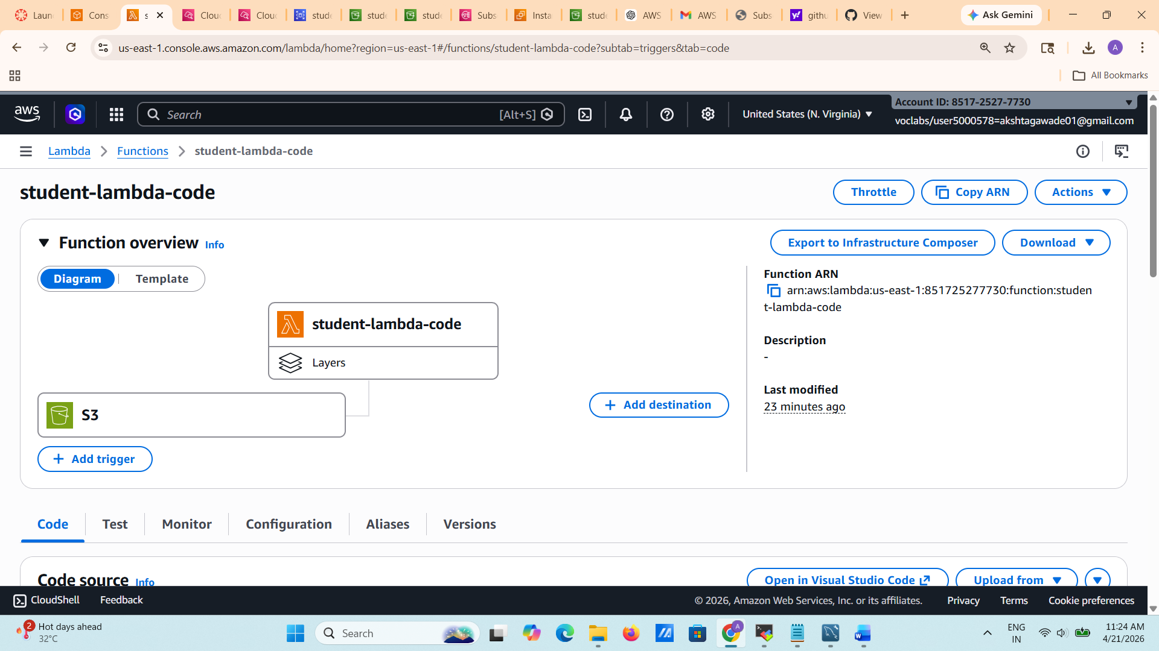
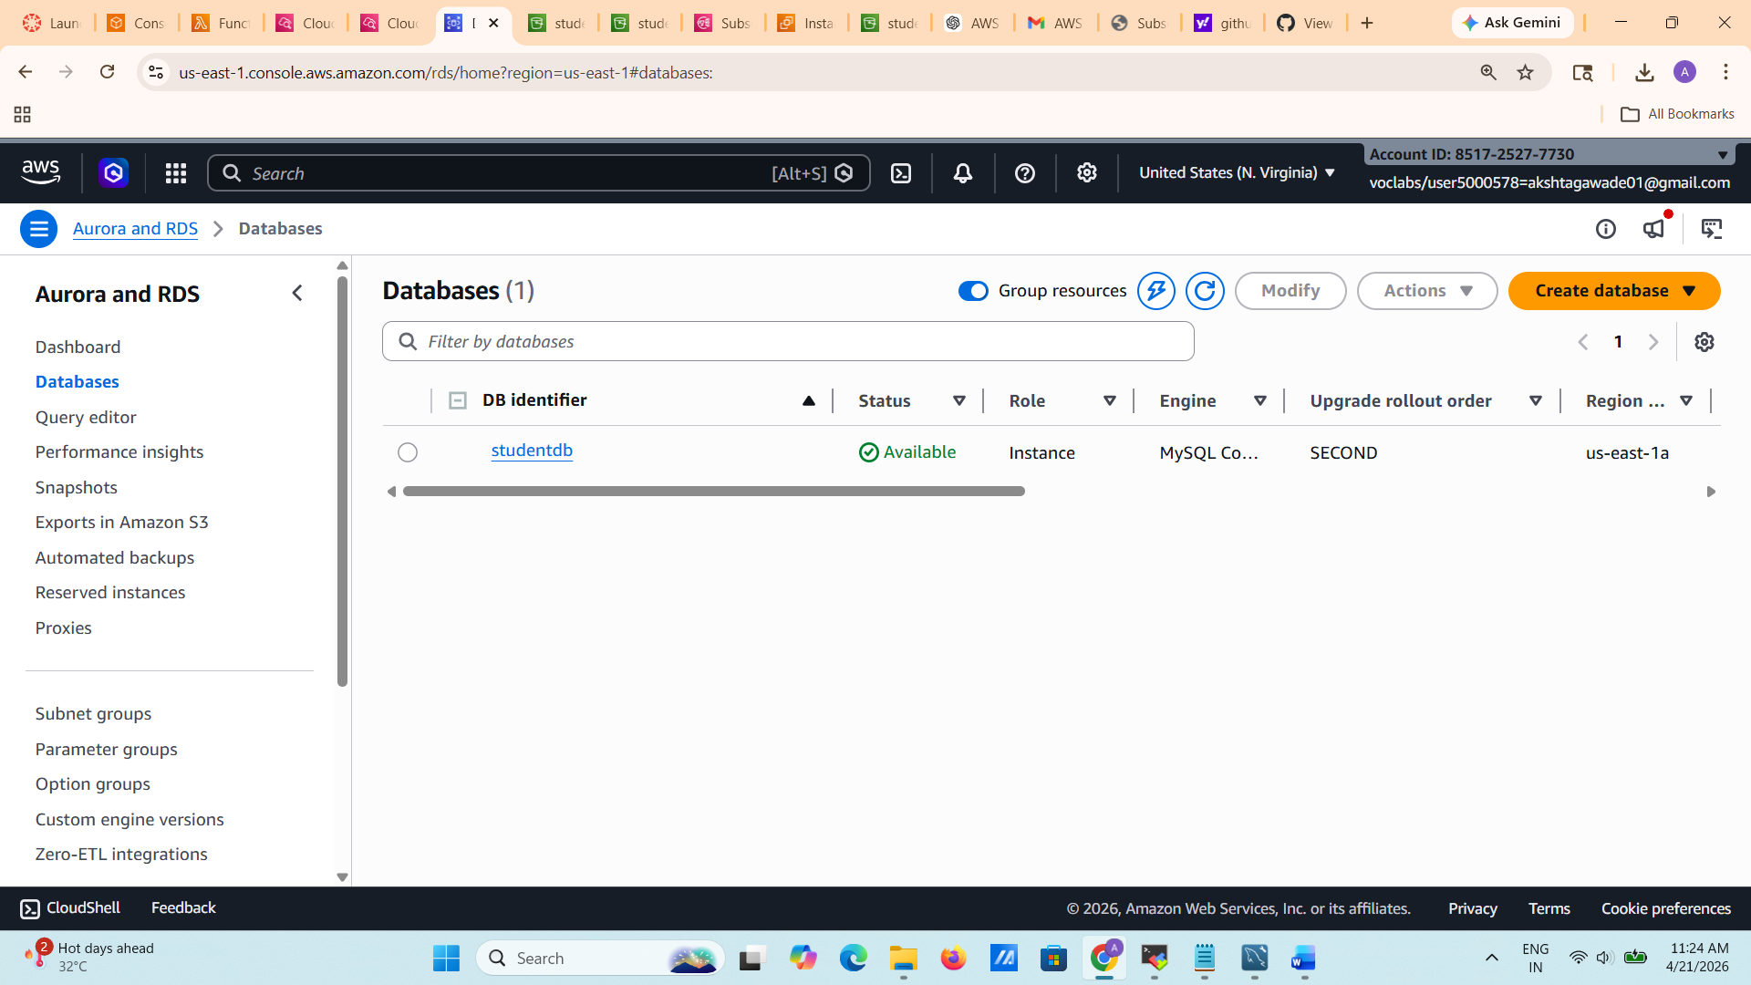

Q.1

